**Audit Airbnb**

**1.design et organisation (par page)**

**Home page :**

It is divided into 5 parts

1. very minimalist(90 % of the space is empty ) :
   1. a search bar in top as the main feature its located in the middle upper part of the page ,has fields that changes and it depends on the menu above it :  
      if u clicked on places to stay : it will be in the format where/check in /checkout /guests.  
      Experiences :location/Date   
      And the third button online experiences where it has no effect on the search bar.  
      It also has a manual click button in red instead of the normal Enter to search scenario
   2. a logo on the upper left of the page
   3. Become a host button
   4. a button to change the language :its a logo of globe
   5. a drop down menu : contains 5 buttons
      1. sign up
      2. log in
      3. Host ur home
      4. Host ur experience
      5. Help
   6. get inspired button
2. white background with filters/buttons that redirect to a filtered search (housing)
3. Becoming a host : contains a button that allows to learn more the proper procedure.
4. Discover Experiences : 3 buttons/pictures that redirect u to different pages of the app
5. two footers/trivia
6. First one
   1. About :
      1. How airbnb work
      2. Investors
      3. Airbnb Plus
      4. Airbnb Luxe
      5. HotelTonight
      6. Airbnb for work
      7. Made possible by Hosts
      8. Careers
      9. Founders’ Letter
   2. Community
      1. Diversity & Belonging
      2. Accessiblity
      3. Airbnb Associates
      4. Frontline Stays
      5. Guest Referrals
      6. Airbnb.org
   3. Host
      1. Host your home
      2. Host an Online Experience
      3. Host an Experience
      4. Responsible hosting
      5. Ressource Centre
      6. Community Center
   4. Support
      1. Help Center
      2. Cancelation options
      3. Neighbourhood Support
      4. Trust & Safety
7. Second one :contains their Legal documents : privacy /Terms
   1. SiteMap:which redirect to all of the destination possible a filter by location

Ps : when u scroll from the first part , the search bar acts like a drop down menu

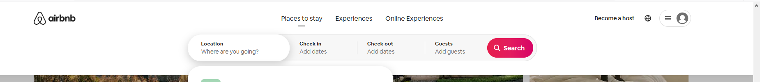

**2- description des boutons fonctionnels (par expérience)**

* a logo on the upper left of the page :redirect to the home page
* Become a host button :redirect to initiate house hosting page (1)
* sign up : initiate the sequence of the signup.
* Login : initiate the sequence of the login.
* .Host ur Home :redirect to (1).
* Host ur Experience :redirect to start experience hosting page (2)
* Help : opens a popup with bulleted point FAQ style .it also has 2 buttons
  + Visit the help center : redirect to the help Page(3)
  + Give feedback :redirect to the Feedback page(4)
* Get inspired button :redirect to a more suggestive page (more user friendly than the home page ).(5)
* Filters that redirect to search page(6)
* Learn more : redirect to (1).
* Featured collection :wanderlust:redirect to redirect to the Online experiences pages(7).
* Online experiences : redirect to (7).
* Experiences :redirect to local experiences based on your location
* How Airbnb works :Redirect to how airbnb works page(8).
  + A page with a step by step on how use airbnb with a red button in top left corner “start ur search ” that redirect u to the Home page
* Newsroom : redirect to News page created by airbnb (empty page).
* Investors : redirect to a financials/investor relation page (9)
* Airbnb Plus :redirect to a home page where the search is always filtered by the plus accounts
* Airbnb Luxe redirect to : Airbnb LuxeHome page (10)
* Hotel Tonight redirect to : Hotel booking page (11)
* Airbnb for Work : redirect to their job appliance page (12)
* Made possible by Hosts : redirect to their Youtube page
* Careers :Redirect to (12)
* Founders letter :Redirect to page . the founder of Airbnb basically describes the app ,addresses the users and the stockholders.
* Diversity & Belonging :Redirect to their community guidelines page
  + It has menu in the top contains 4 buttons Become a host /Help/Sign Up /Log in
* Accessibility : redirect you to page that describes their future goals
* Airbnb Associates : redirect to associates page :with a button of login if u are already one because they aren't accepting new ones .
* Airbnb.org: redirect to they charity organizations
  + They describe who they are and what are their current charity events/projects
  + A donate button

**3- Sequences**

* initiate the sequence of the signup.

1. Clicking on the buttons opens a popup(Modal)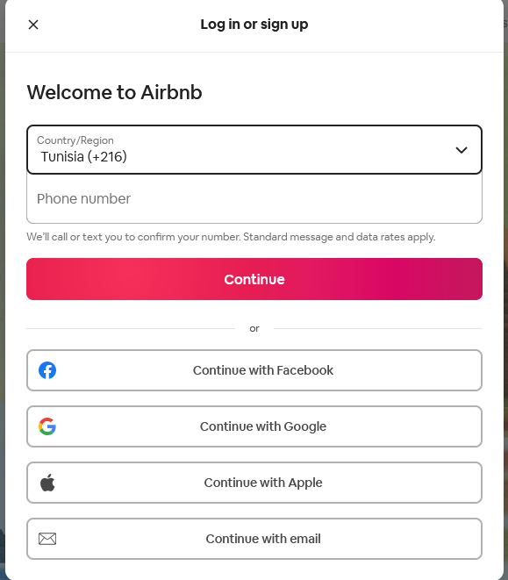
2. U have two methods to continue
   1. Typing ur number will permit u to create an account by typing Verifcation code that receive to your phone
   2. By using An email address either provided by on of the api or manual

Ps : in both cases its a simple one step verification process

Also the u can create an account from the same interface if u dont have one

* initiate the sequence of the Log in

1. If u the app doesn’t find a cookie in your browser it always redirect you to the signup/login page
2. If it does it will open a Popup(Modal) with ur saved cookie 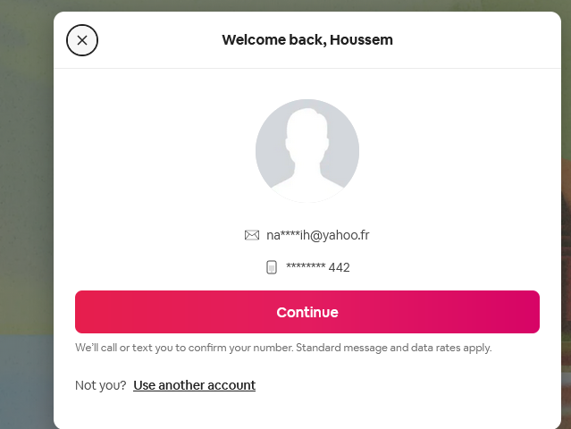

**1.design et organisation (par page)**

**House Hosting page**

1. Explains what is hosting with images and text, contains links to different necessary informations about the process
   1. Why host on Airbnb?
   2. How to get started on Airbnb
   3. How to earn money on Airbnb
   4. Is my space a good fit for Airbnb?
   5. What does Airbnb expect of Hosts?
   6. What hosting regulations apply to you?
2. Get started button found in multiple places. You encounter it first at top of the page 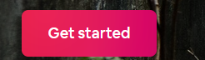  
   When scroll the page it also appears like a drop down menu  
     
   And then 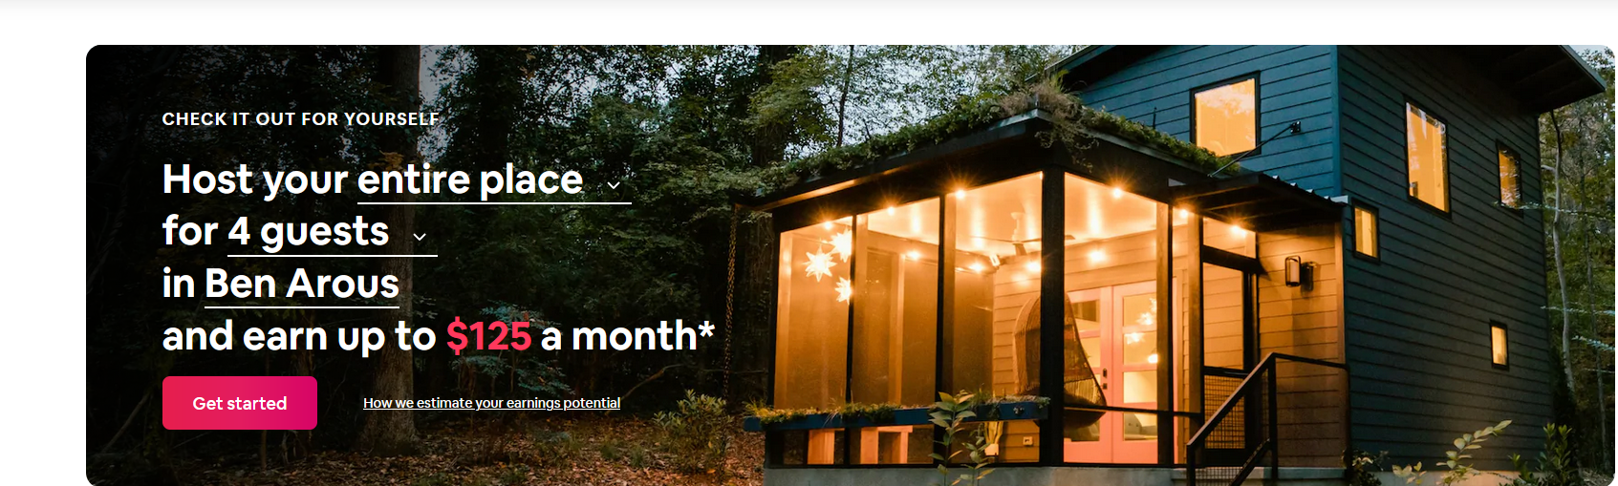
3. Get answers from Hosts : lets email hosts from your location

**2- description des boutons fonctionnels (par expérience)**

* Get started : initiate the hosting process

**3- Sequences**

* initiate the hosting process
* 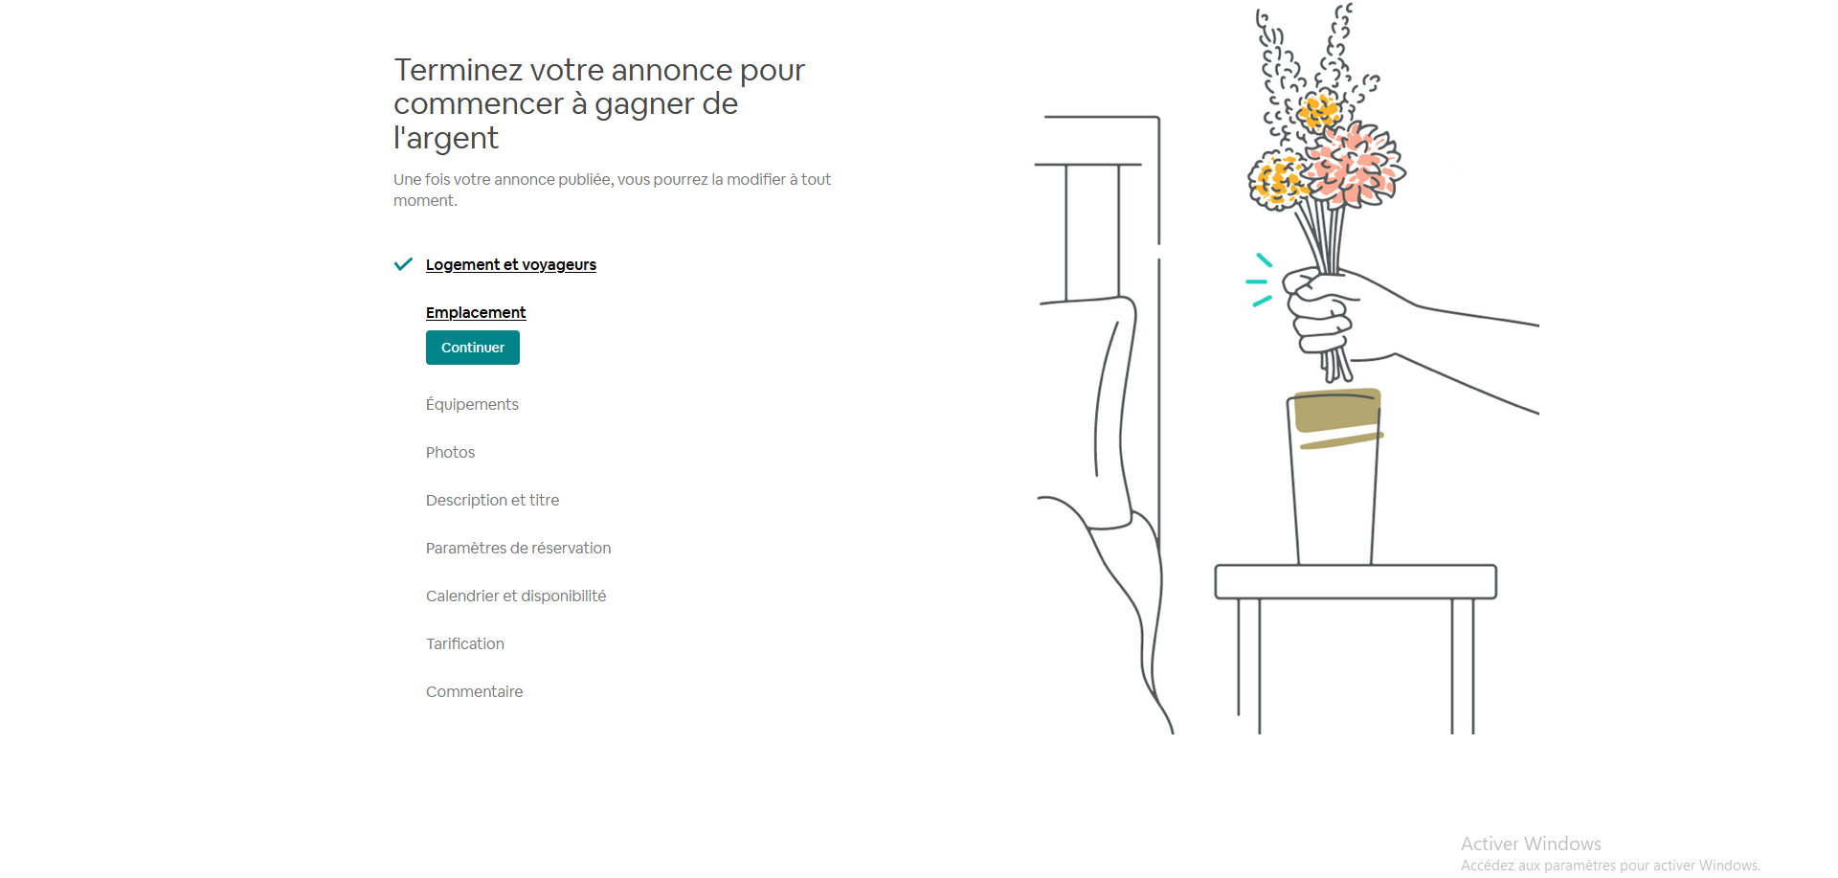

1. Form page that is presented to the user portion by portion
2. 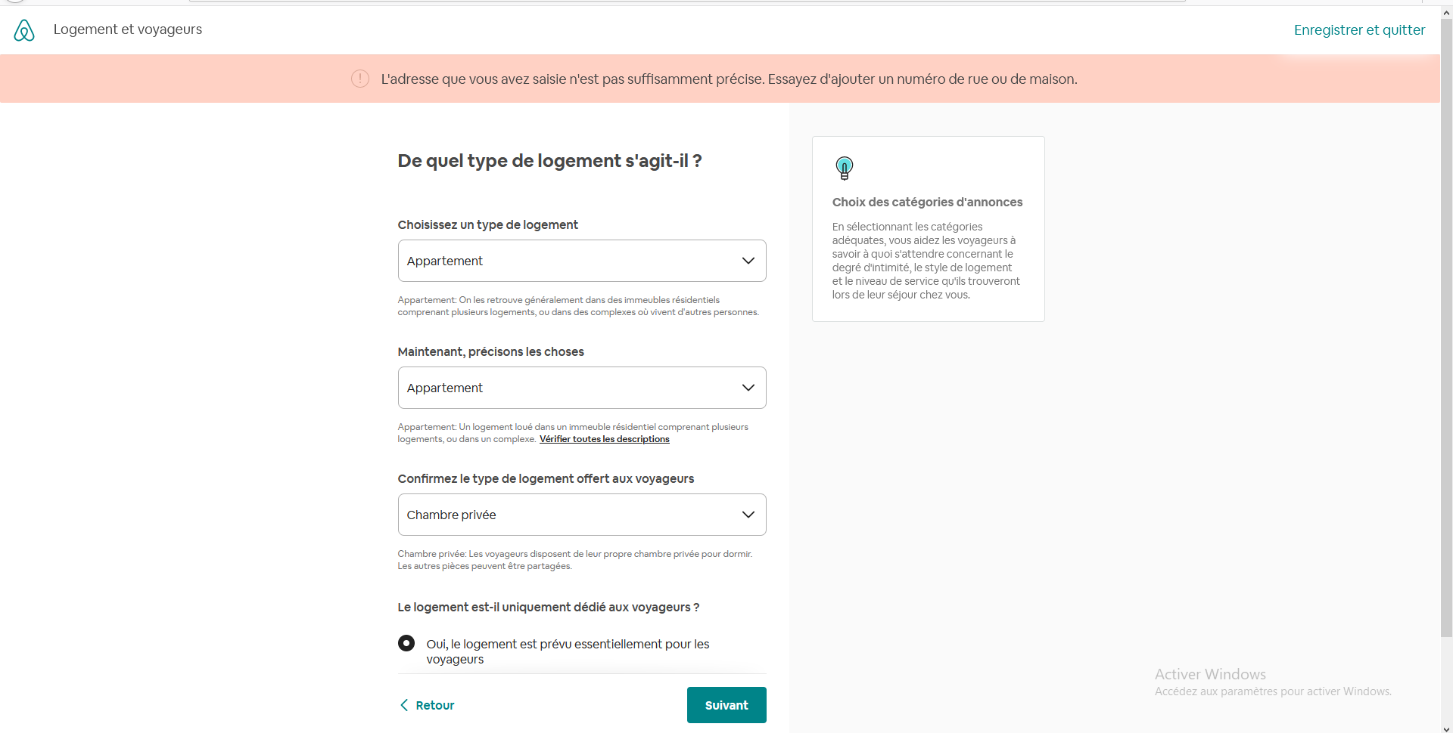

**1.design et organisation (par page)**

**Experience Hosting page**

Its page each 5-6 lines there’s a button of to start creating ur experience

It also explains with pictures and texts whats an experience

**2- description des boutons fonctionnels (par expérience)**

* Commencer : initiate the hosting process
* Show all experiences : redirect you to (7)

**3- Sequences**

**Hosting sequences : it has the same idea as the house hosting its form divided into portions so its doesnt overwhelm the user**

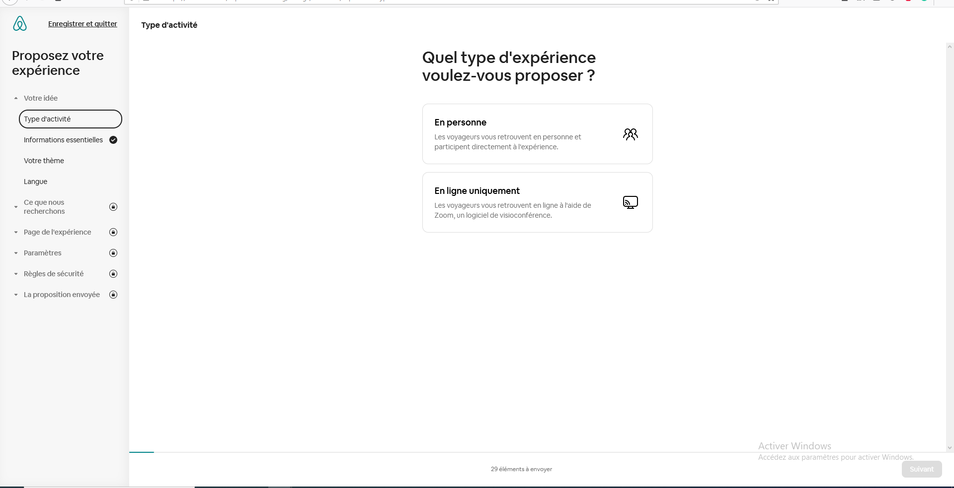

**1.design et organisation (par page)**

**search page:**

It is divided into 4 parts

1. Filters with categories   
   
2. Filters about best experiences in the place u searched and it also contains the most popular categories in that place for example 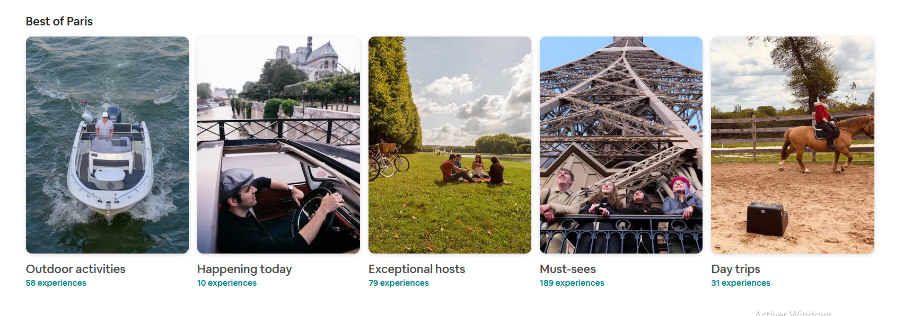
3. All the experiences :
   1. A sample of 4 rows by six experiences in each row 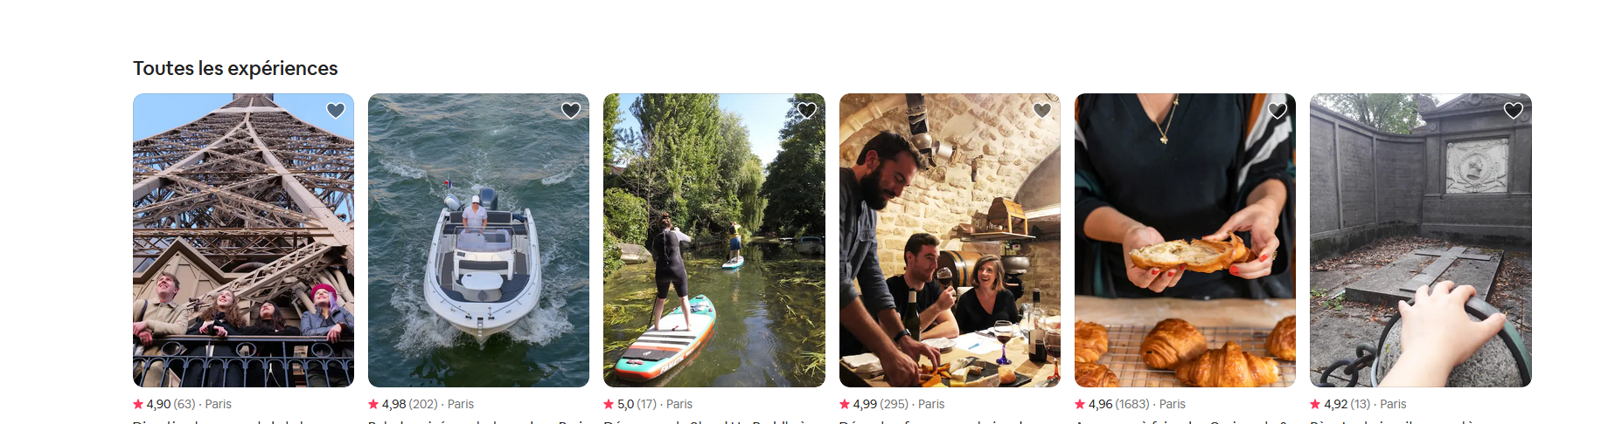
   2. Loadmore button
   3. **Introducing Online Experiences :** a sample of online only experiences 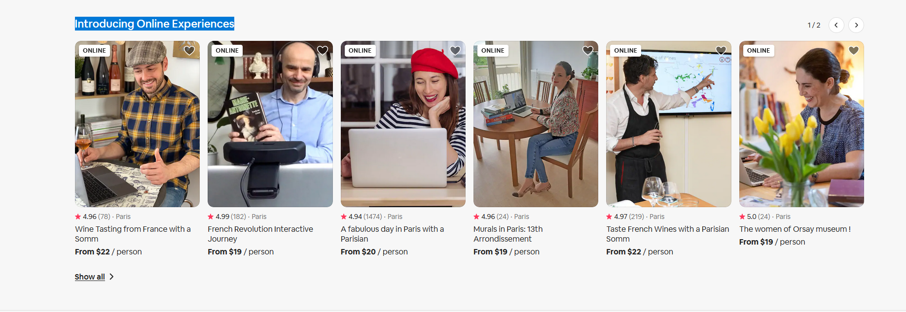  
      They are clickable cards that redirect you the experience
4. Same footer found in the home page

**2- description des boutons fonctionnels (par expérience)**

1. LoadMore:A click to show more button that adds 4 rows each time u clicked into the same page

**1.design et organisation (par page)**

**An experience page :**

Starting from the top

1. Name of the experience
2. Rating location
3. 3 buttons Gift /share /Save
4. Media portions which can contain video or images
5. 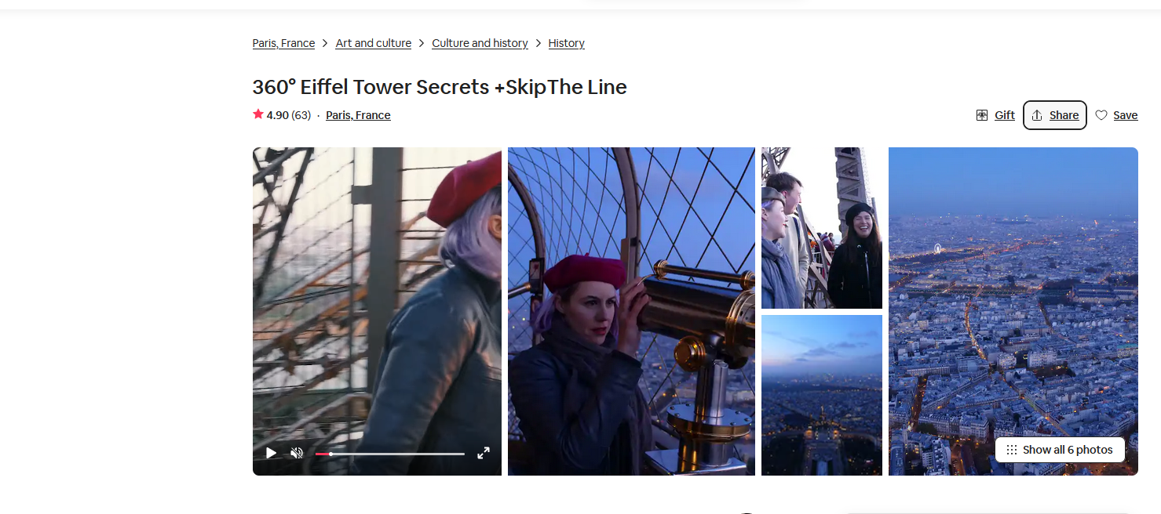
6. The host and the length of the experience  
   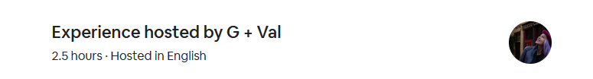
7. Safety regulations
8. Number of maximum attendance
9. Includes what and the category of the experience
10. 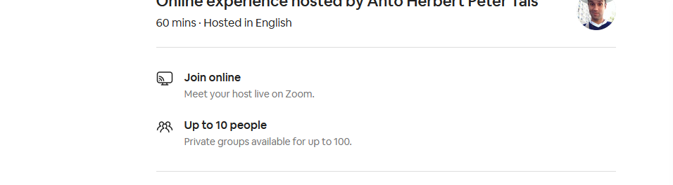
11. Description of the experience 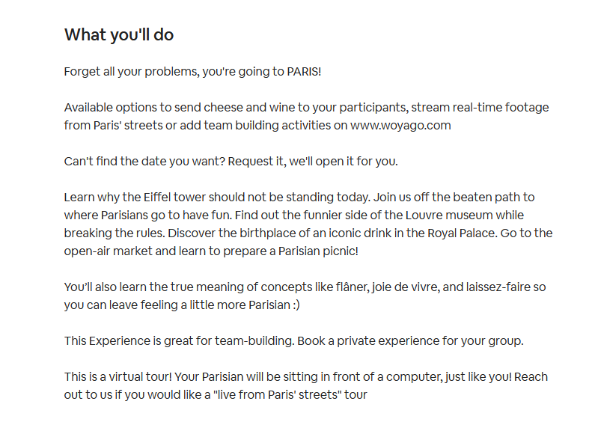
12. More in depth of what included
13. 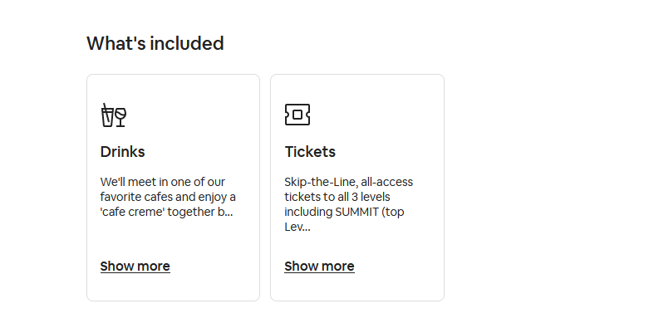
14. Reservation tab   
    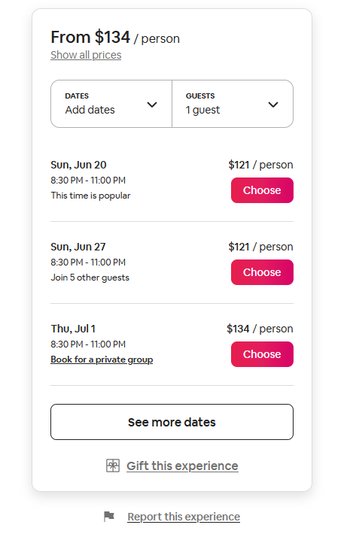  
    which contains
    1. Price
    2. Dates button
    3. Guests button
    4. Choosing an available date
    5. Seeing more dates button
    6. Gift this experience
    7. Report this experience
15. Description of the host   
    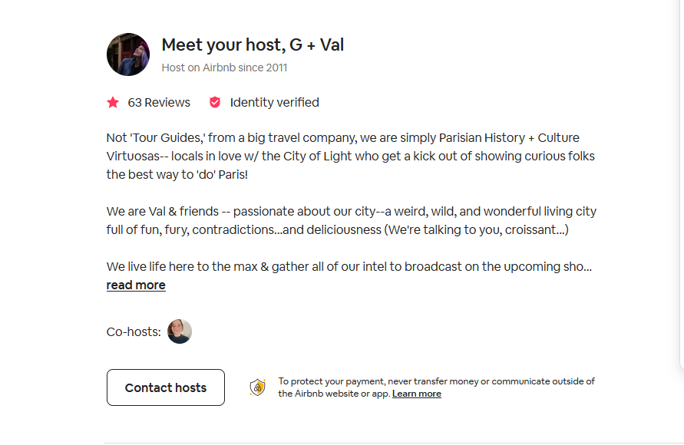
16. Location

Both written one and shown on a map   
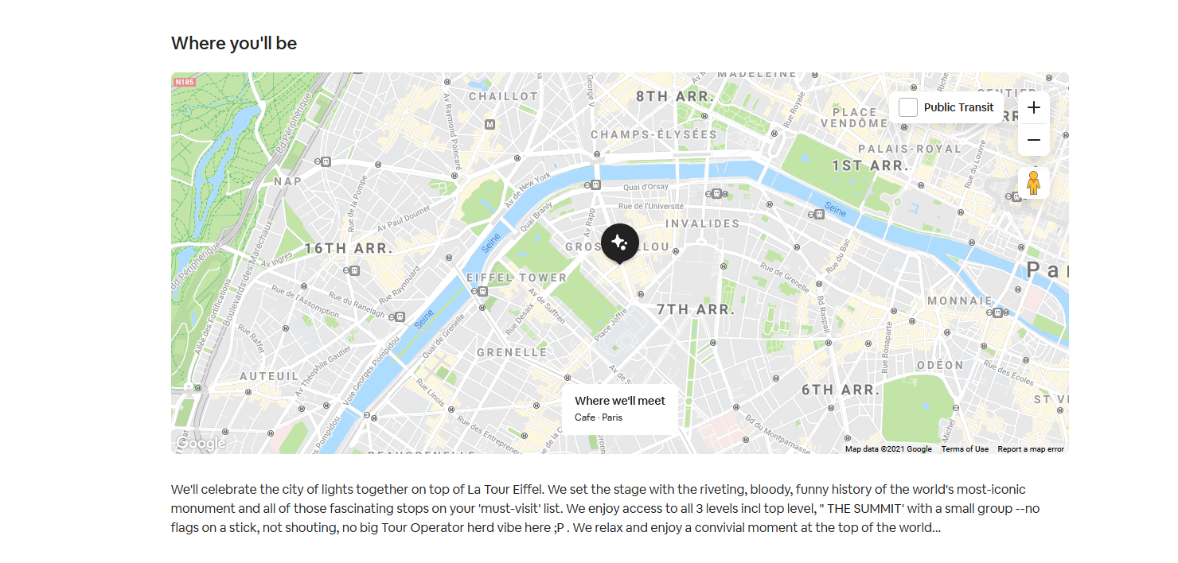

1. Comment section   
   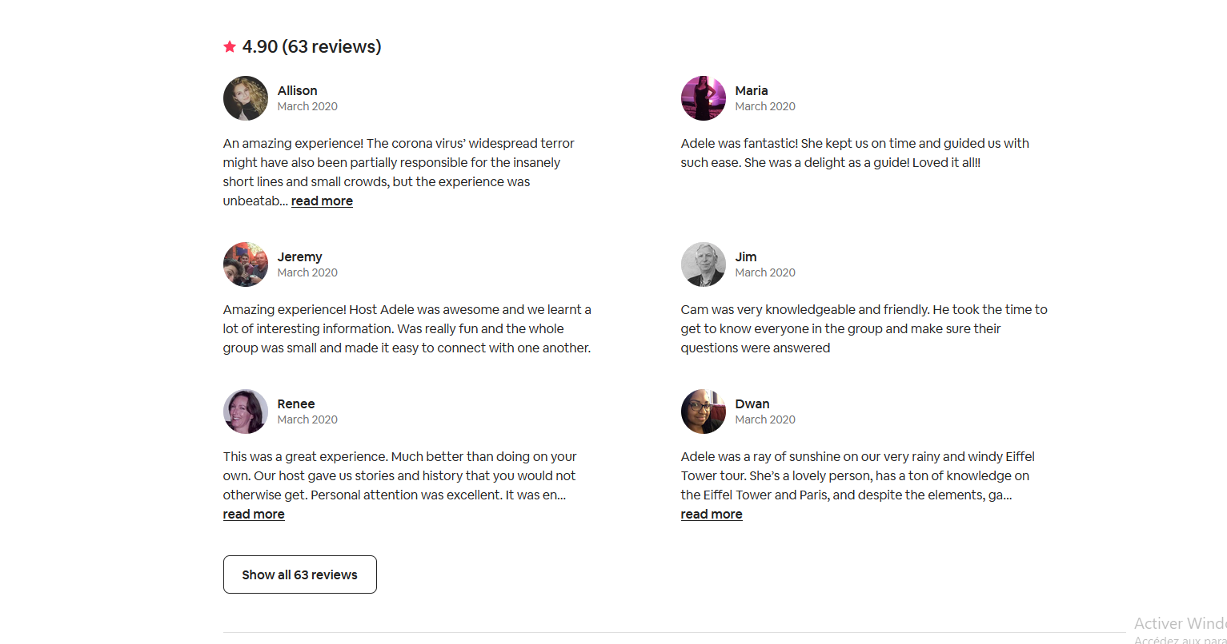
2. Dates available 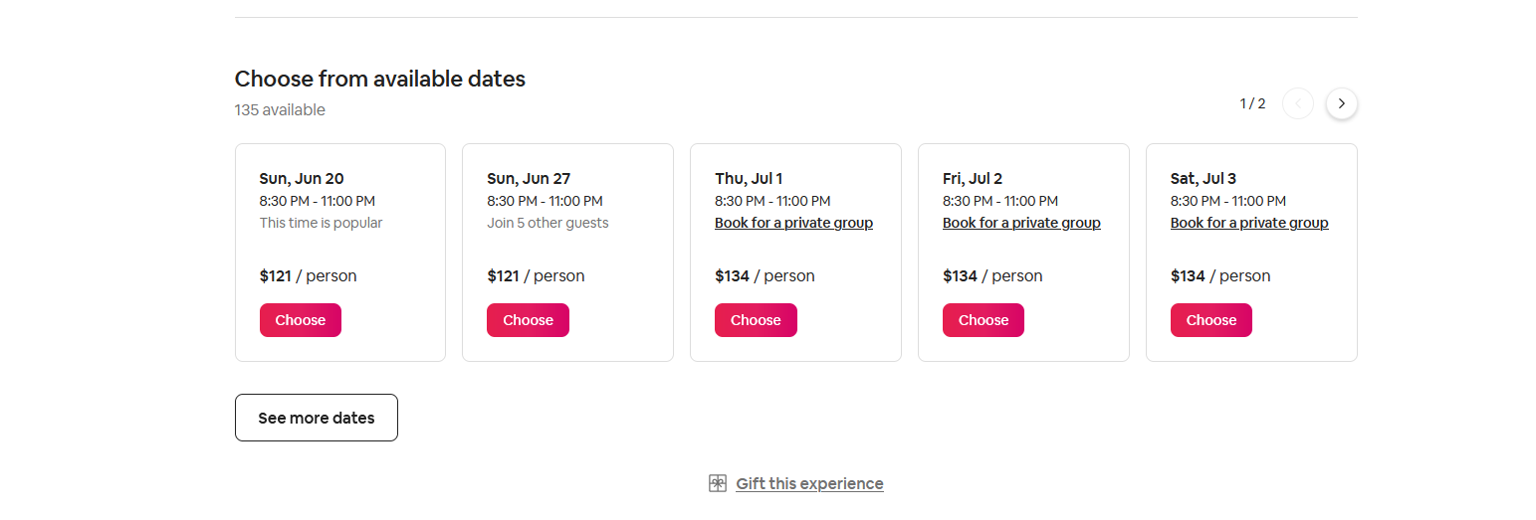
3. A things to know section , what to bring requirements ...etc   
   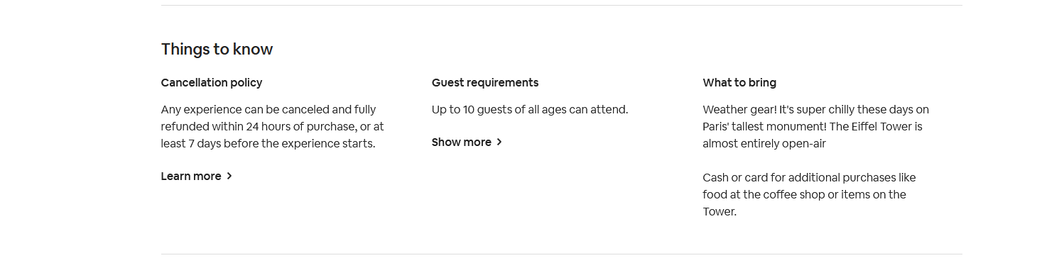
4. Experiences of the same place and same category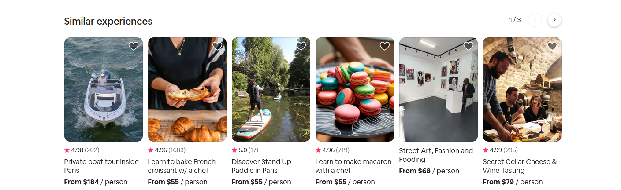
5. Category Filters about the same location of the experience

**2- description des boutons fonctionnels (par expérience)**

* Dates button : It opens a calendar where u can input the date of the Booking  
  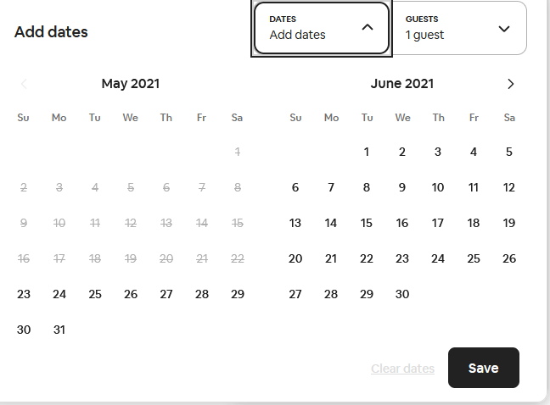
* Number of guests where u can input number of guests to   
  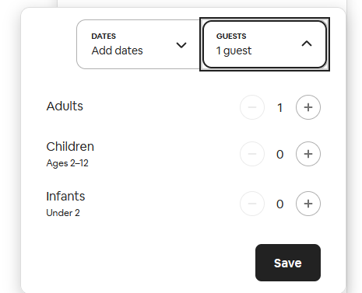
* Choose : opens the booking page (13)
* See more dates:
* Gift this experience: initiate the gifting sequence
* Report this Experience :initiate the reporting sequence
* Share : lets you share this experience to social media platforms,emails ,messaging platforms or by a link
* Show all photos :redirect you to page where u can view all the media in a carousel situation
* Contact hosts :opens a popup(Modal) where send a message to the host on 3 categories
  + Requesting a specific date
  + Requesting a private group
  + Something else
* Shows all reviews :
* Show all experiences

**3- Sequences**

1. Gifting Sequence
   1. Clicking on the button opens a pop up  
      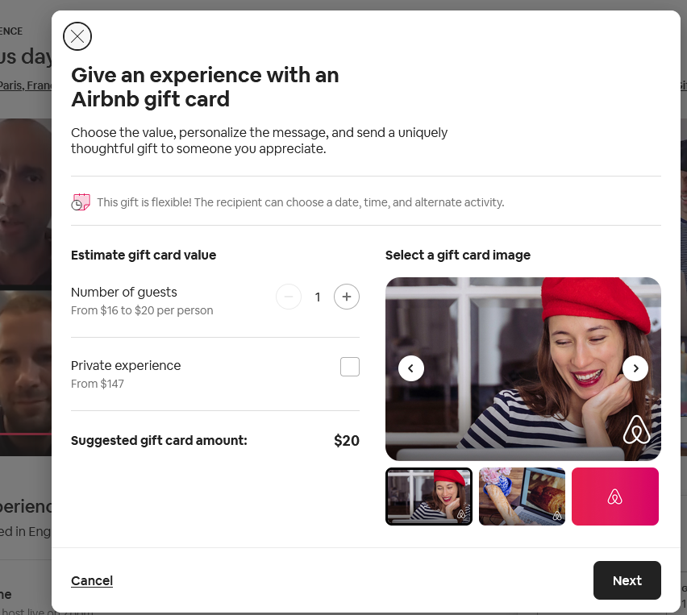
   2. After choosing the option and number of guests pressing on next redirect to a gifting page(13)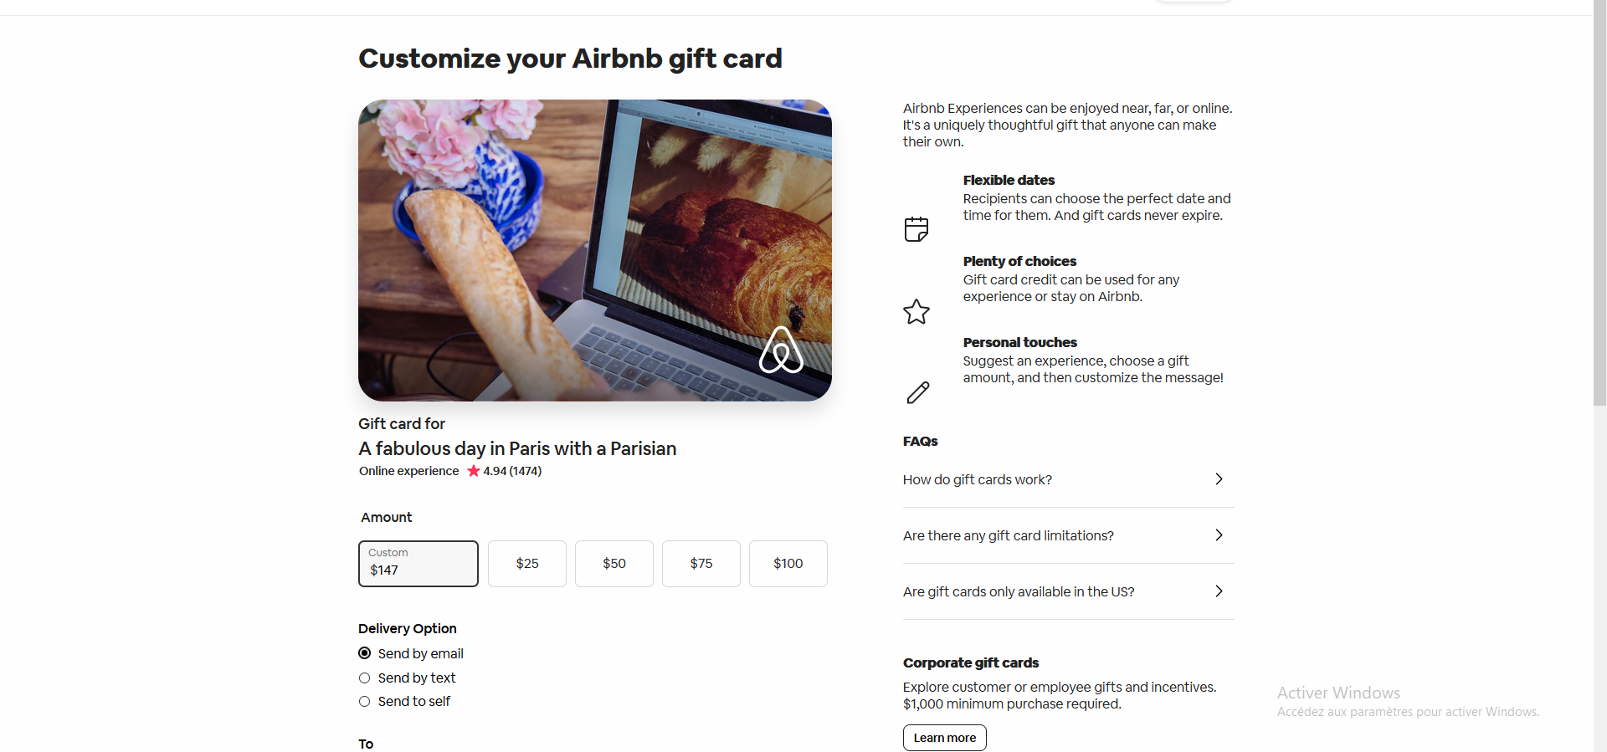
   3. 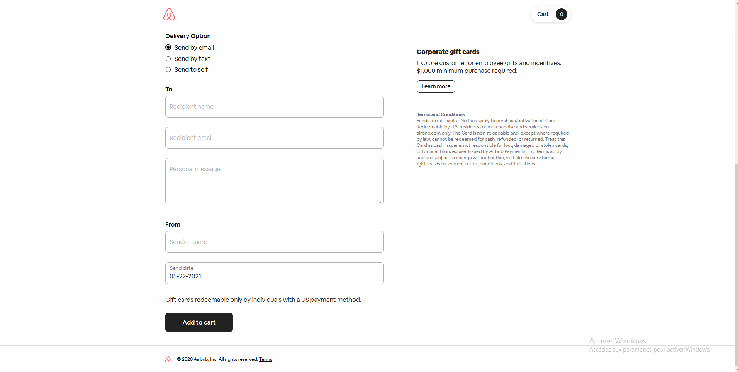
2. **design et organisation (par page)  
   Gifting page:**
   1. **Image of the card the friend will of emails**
   2. **Description of the gifting system how it works ...etc**
   3. **An FAQ section**
   4. **A form where u can fill the amount u want to gift**
   5. **Radio button to choose how to send the gift**
   6. **Add to cart button**
   7. **A cart that will save the current gift so each time u click on add to cart u add the same gift**

**1.design et organisation (par page)  
 Booking page :**

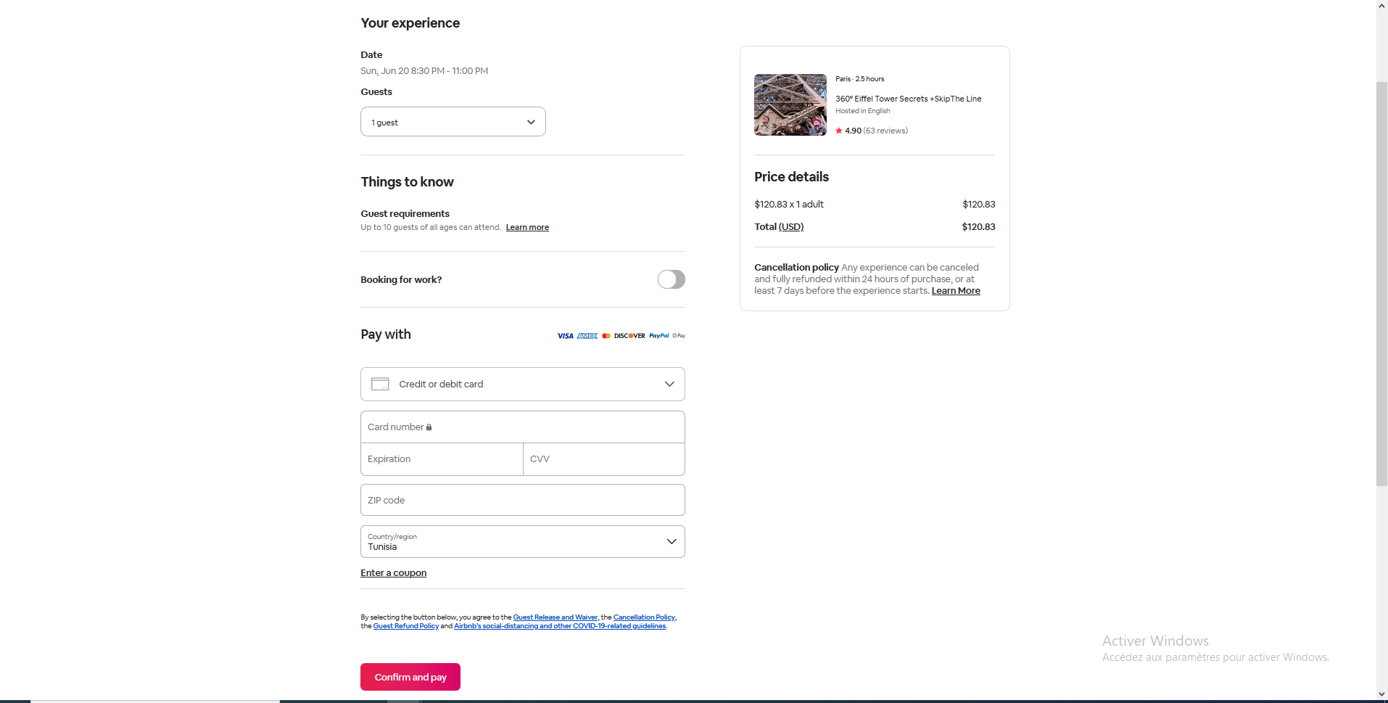

It’s composed of three parts

1. Confirmation
   1. Date :shows the date of booking you choose prior
   2. Drop down menu lets input number of guests Contains a save button   
      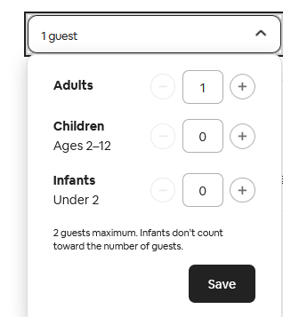
   3. Requirement: legal documents to know
2. A Card that contains :  
   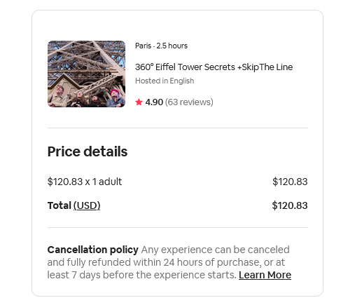
   1. A picture of experience
   2. Length of the experience
   3. Name of the experience
   4. Language
   5. Rating and number of reviews
   6. Price details :that's calculated based on the number of guests.
   7. Informations about Cancelation policy
   8. Learn More button
3. Payment section   
   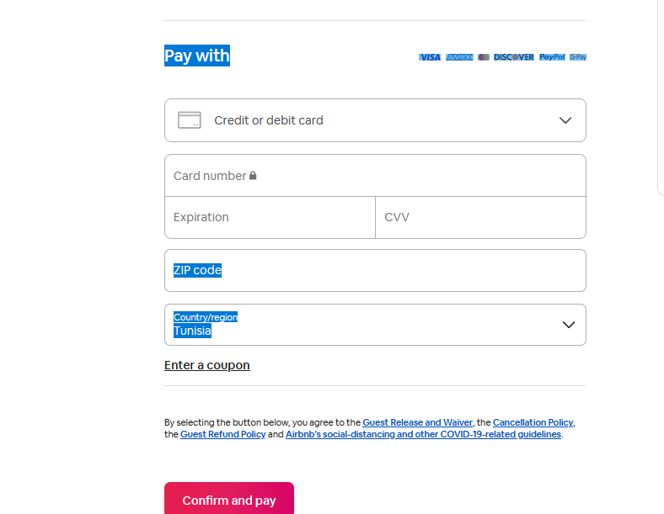
   1. A drop Down List that contains payment options
   2. A payment form that changes depending the option u choose from the prior list , there 3 variants
      1. 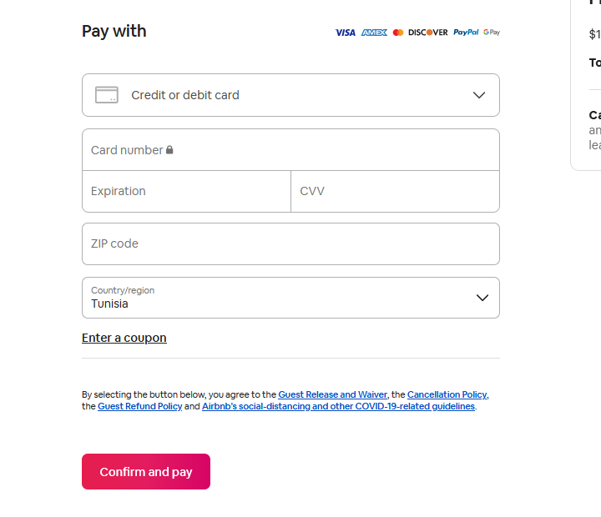
      2. 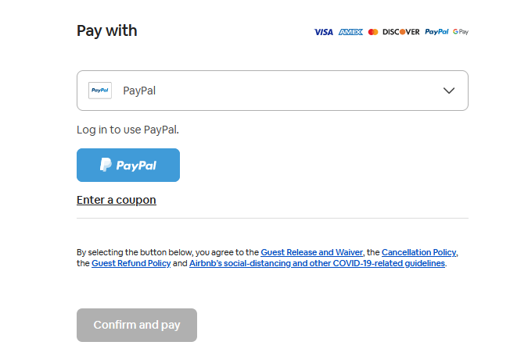
      3. 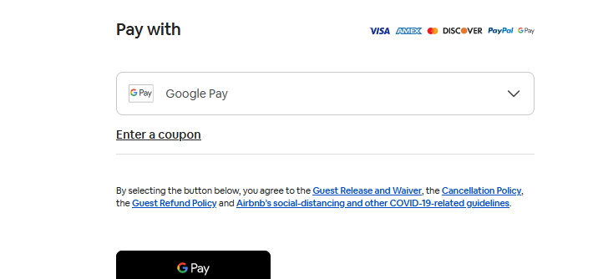
   3. A button that initiates the payment sequence .

**1.design et organisation (par page)**

**Help Center**

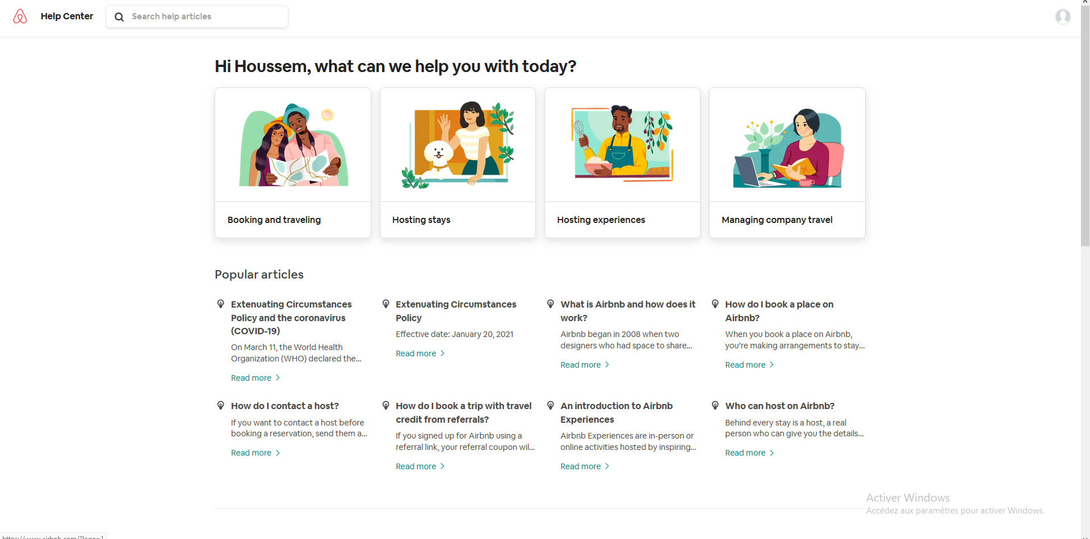

1. Nav Bar in the top contains :
   1. Logo button that redirects to (1)
   2. Help center button that redirects to (3)
   3. Search that allows you to search for articles and protocols of Airbnb
2. Four filters by Articles category
3. Links to popular articles
4. AirBnb Basics: redirect you to FAQ about different topics
   1. About Airbnb   
      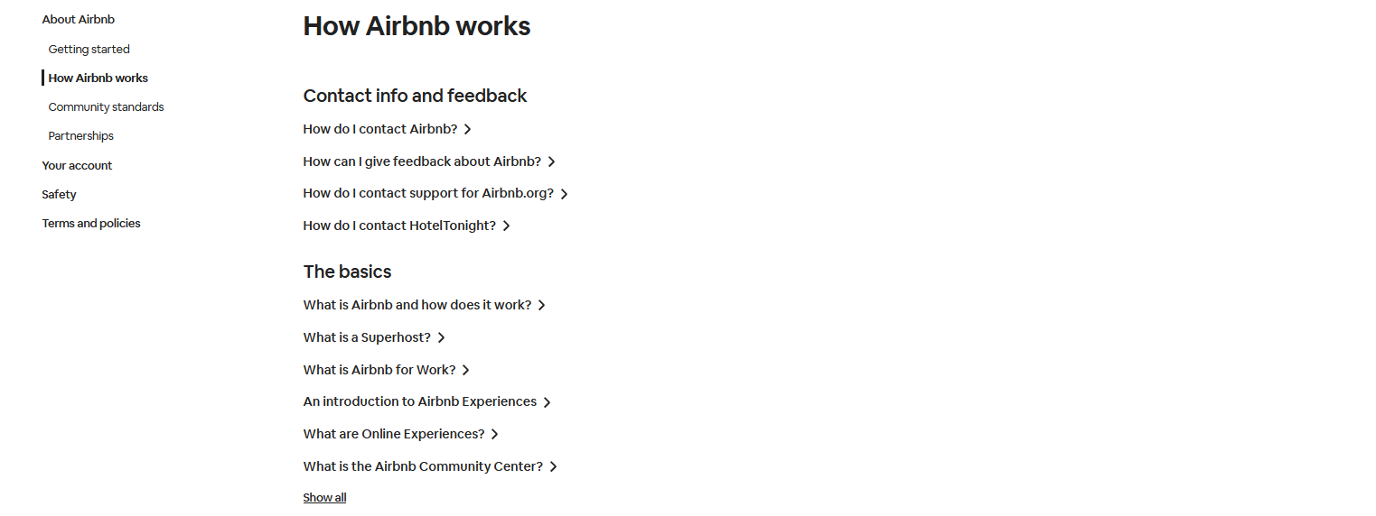
      1. Getting started :summary of how to use Airbnb
      2. Community Standards
      3. Partnerships
   2. Your Account
      1. Creating your account
      2. Managing your account
      3. ID and verification
      4. Account and security
      5. Reviews
   3. Safety
      1. Safety Concerns
      2. Safety tips and guidelines
      3. Reporting issues
      4. Government travel restrictions
   4. Terms and policy
      1. Terms of service
      2. Payments Terms of service
      3. Privacy Policy
      4. Privacy policy Supplements
      5. Member policies and standards

**1.design et organisation (par page)**

Airbnb Lux Home page

Its Constituted of :

1. First part which is minimalist(90 % of the space is empty ) with a search bar in the middle   
   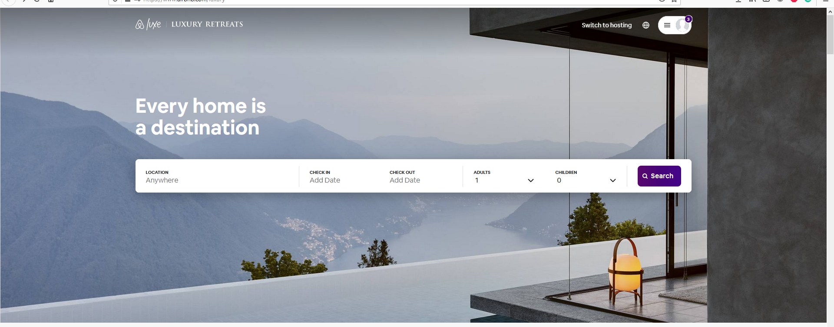
   1. The search bar follows the format :Locations/Check in date/check out date /number of Adults/Number of children and manual clicked Search button .Can initiate the search by filling just one criteria .
   2. Filters by place ,clickable images   
      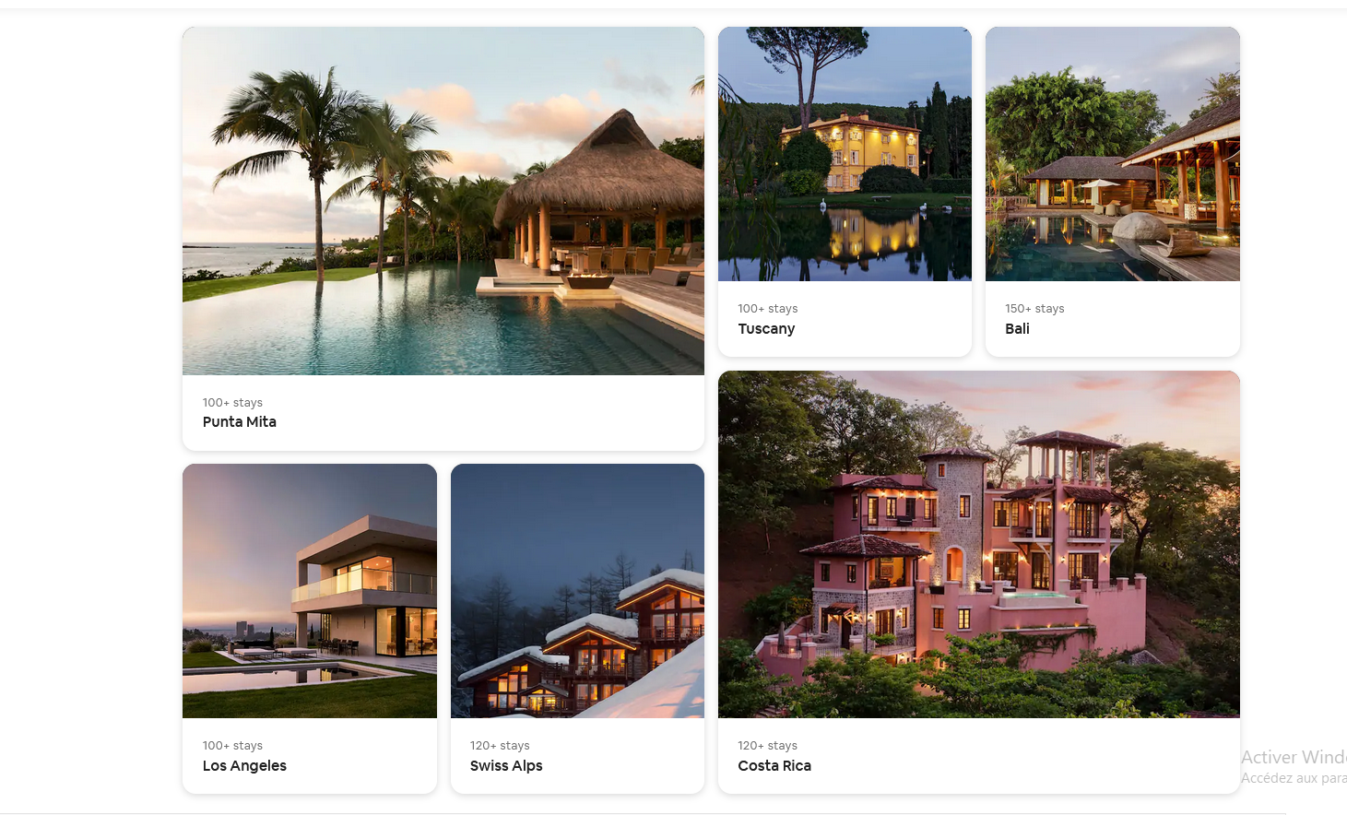
   3. Description of what u expect to get from the experience of Airbnb lux

And main differences between normal Airbnb and lux Aibnb   
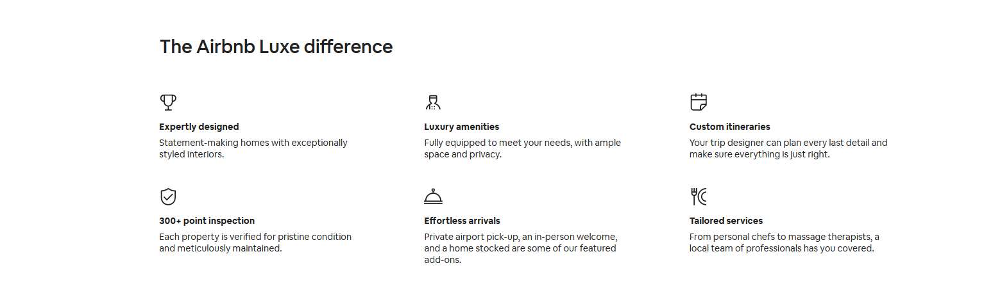

* 1. Three filters
     1. Flexible bookings : a filter that redirect you to large housing
     2. Featured Homes : Homes promoted by Airbnb
     3. California beach side houses
  2. Suggesting the fact you can pretty much customize the whole experience 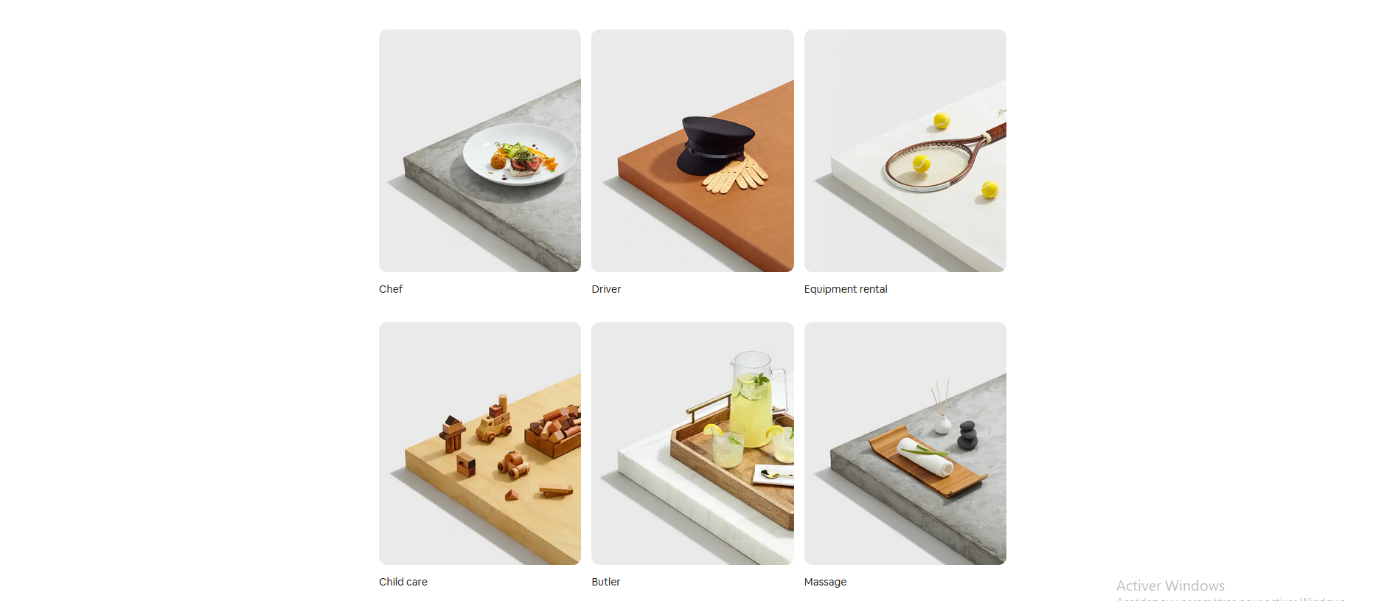
  3. A promotional Video
  4. Locations that contains Airbnb lux houses   
     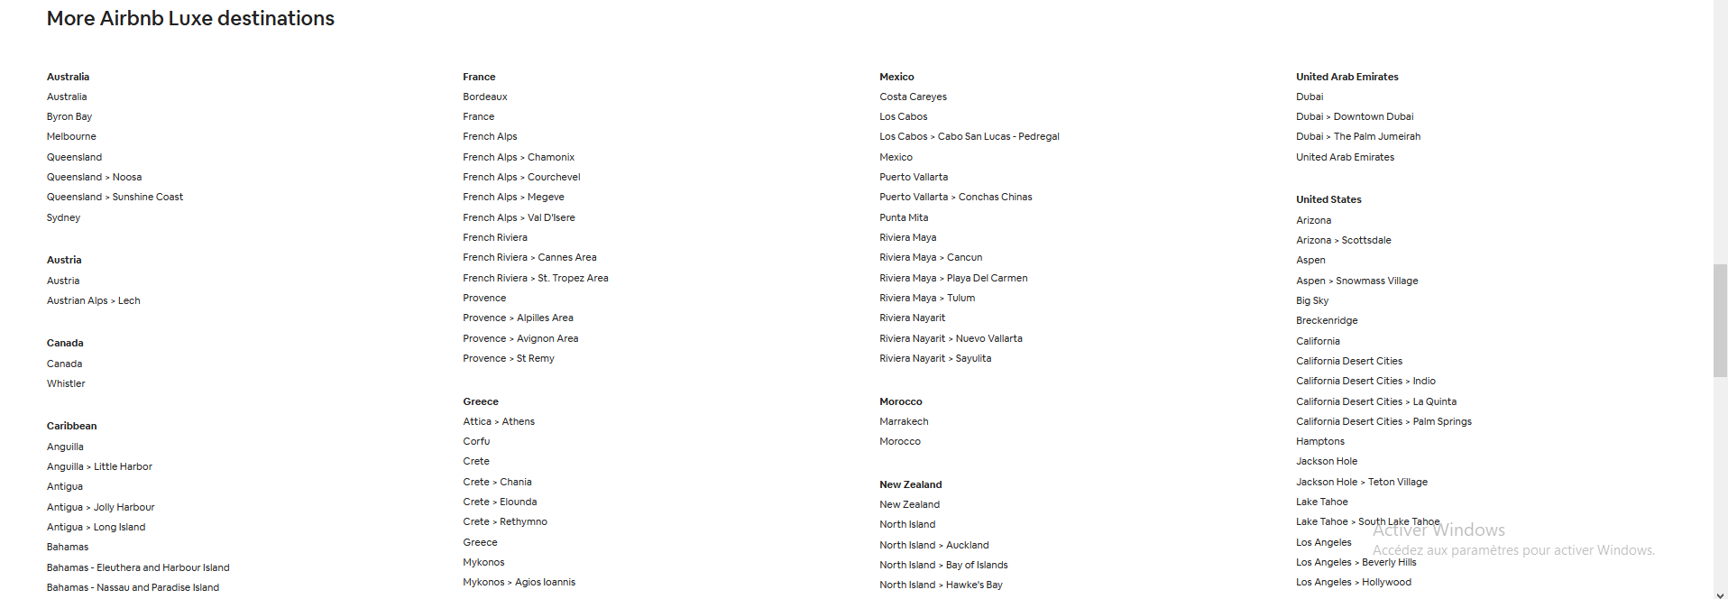
  5. Same footer as normal Airbnb

**Airbnb financials Page**

Contains

1. Upper Navbar   
   
   1. Logo button:redirect to the initial page(9)
   2. Airbnb Investor Relation : It’s a button that redirects to the initial page (9)
   3. Events and presentations
   4. Press Releases
   5. Stock Info
   6. Financials
   7. Governance
   8. Ressources

**description des boutons fonctionnels (par expérience)**

* Events and presentations :Redirect you to the events & Presentations page which contains nothing